

**GENERAL HUMAN BIOLOGY – YEAR 11**

**TASK 1 – MICROSCOPE SLIDES AND USES PRACTICAL**

**WEIGHTING: 10%**

**NAME: ___________________________________**

**DATE: _____________________ MARK: _____ /38 = _____ %**

**Part A: Identify the unknown samples using your knowledge of different tissue types** **10 marks**

1. Look at the slides under a microscope to determine which of the slides is: (3 marks)

Red Blood cell, Liver Cell and cerebral cortex

|  |  |
| --- | --- |
| slide | Identity |
| Green |  |
| Orange |  |
| Black |  |

1. Explain how you knew you had correctly identified each slide (3 marks)

1. Using the images below determine which is the healthy tissue and which is unhealthy (2 marks)

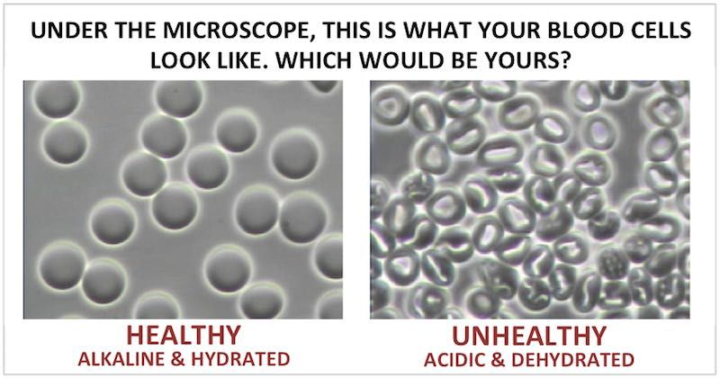

Identity:

1. How did you distinguish between the healthy and unhealthy tissue (2 marks)

**Part B: Scientific Drawing** **11 marks**

1. For one of the slides from question 1 draw a scientific diagram in the circle below (5 marks)
2. Before removing the slide show the teacher (2 marks)
3. Collect a microscope slide with the letter ‘e’ on it. Place it on the stage and in the space below, draw what you can see when looking down the eyepiece on the lowest magnification (1 mark)
4. Describe what has happened to the image? What do you think is inside the microscope that causes this?

(3 marks)

**Part C: Body Organisation 8 marks**

1. Complete the diagram by stating the level shown at each number. (2 marks)

1:

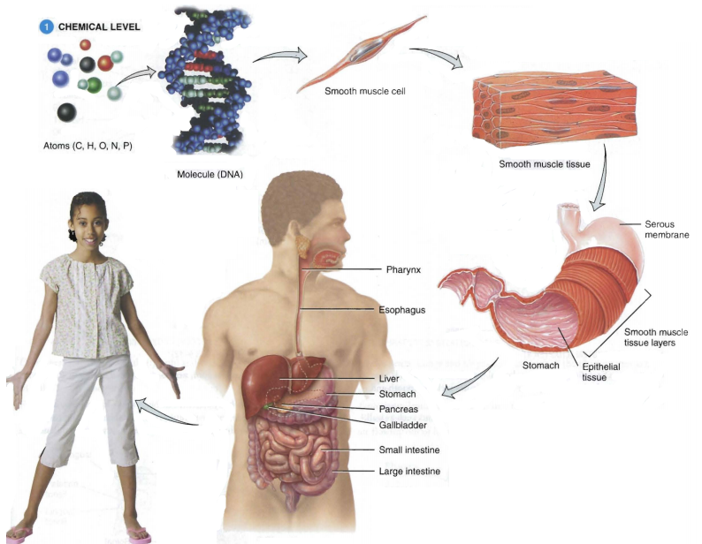

4:

5:

3:

2:

1. Which level of the structural organisation is composed of two or more different types of tissues that have a specific function? (1 mark)

1. At which level does respiration occur? Explain your answer. (2 marks)

**Part D: Characteristics of life** **11 marks**

1. Draw a diagram to represent a cell membrane (6 marks)
2. Using the Picture below, explain how osmosis works when cells are placed into a hypotonic solution.

(3 marks)

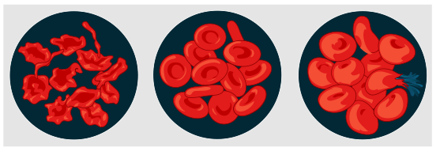

1. Nikki looked through a microscope and saw lots of black dots in a pancreatic cell but when she looked at a blood cell she only saw a few. Explain this statement in detail. (3 marks)